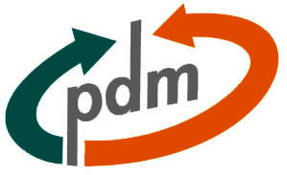

Instructions to make a PDM feedback request

The Whole Process
All feedback is collected and requested by using Training Feedback Lotus Notes-database on vhon08-server.
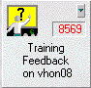
To start Training Feedback system you need to get access rights to the database. To request access rights to the system, contact Pertti Ahonen, +358 20 28 25555
When you have proper access rights to the system, to start the feedback request process just double click the icon of the database. The database opens.

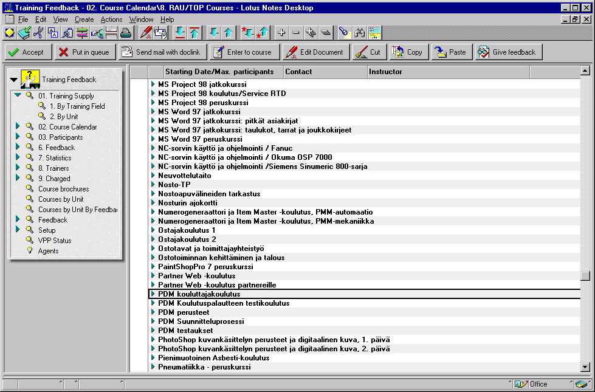
To request feedback you have to create a new course to the database.
The new course is created according to following instructions:
- Select from the navigation window category 01. Training Supply → 1. By Training Field or 2. By Unit
- Click the Create New Course -button The New course creation form opens:
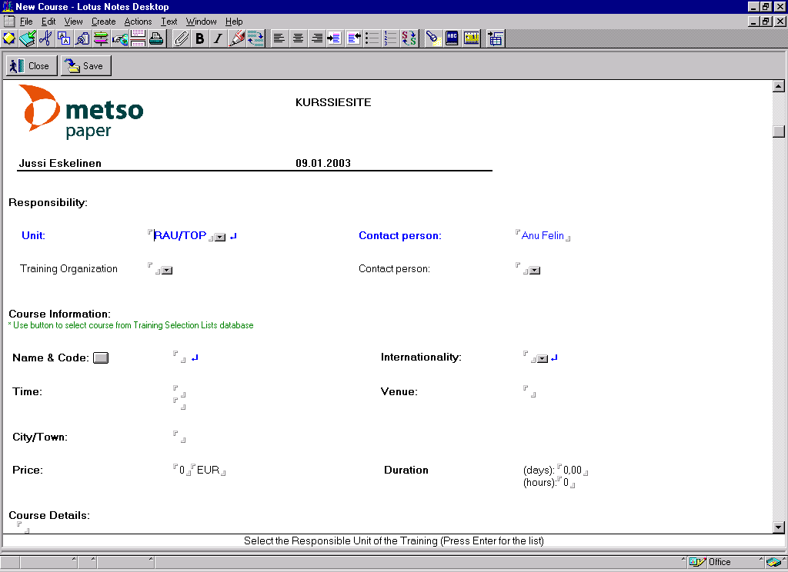
- Fill in the following Course data:
- Unit - Select the unit abbreviation that arranges the course
- Contact Person - Name of the contact person
- Name & Code - Click the button next to the field and select the category Information Technology and subcategory Product Data Management --> click OK. When you have done this you can write the real course name in to this field.
- Internationality - Select the level of internationality of the course
→ Save → the new course has created

- Select the course that you have just created. (01.Training Supply → By training field → Information technology → Product Data Management → “your course name”)
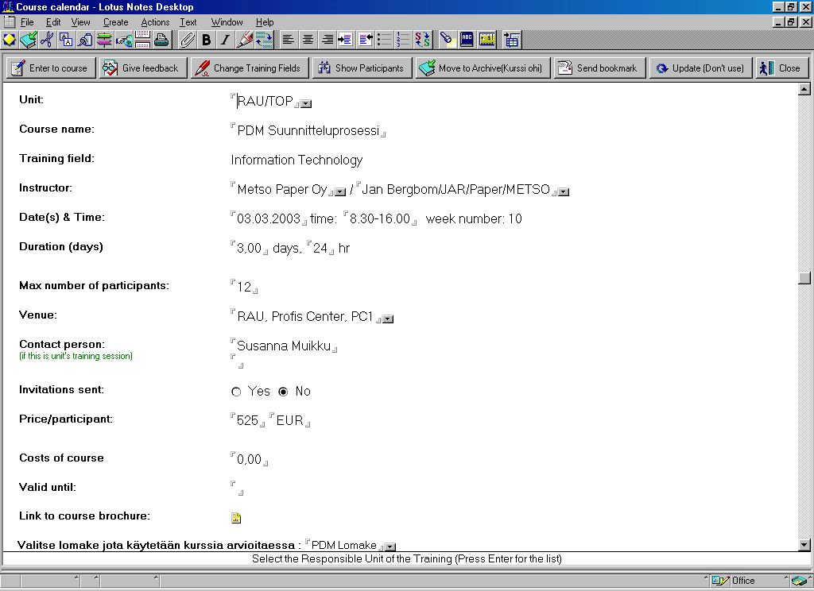
- Press the Add To Calendar –button . Course information window will open:

- Fill in the course information: (Bold attributes are mandatory!)
- Unit - Is the abbreviation of the unit that arranges the course
- Course name - Input name of the course (this field is filled automatically but it can be modified)
- Instructor - Name of the trainer
- Date(s) & Time - Input date and time, week will be corrected automatically
- Duration – Enter the course duration in days.
- Max number of participants - Insert max number
- Venue - Where the course is held
- Contact Person - Name of the contact person
- Invitations sent - Not needed
- Price - Not needed
- Costs of course - Not needed
- Valid until - Not needed
- Link to course brochure - Link to the course information that you have previously created
- Valitse lomake jota käytetään kurssia arvioitaessa - When arranging PDM courses use PDM Feedback -form (english) or PDM palautelomake (finnish)
- Further information - Fill in further information if needed
- Save and close

NOTICE! If you will arrange the same course again you can use the same course information again and again. You just have to copy - paste it and change the needed information (e.g. time and venue) Do not use the copy - paste method if the unit, traininig field, course name or the feedback request form is changed.

Next send the Feedback request by e-mail to course participants. Use the following template:

Hello,

Please, give feedback for XXXX (e.g. PDM test course) kept on (e.g. 2nd July) DATE.

INSTRUCTIONS FOR GIVING FEEDBACK

Click the document link => <Document Link to course brochure (the document in 02. Course Calendar → 4. By Training Field → “unit” → “year” → Information Technology → Active Courses → “your course name”) >
Click the button (upper left corner of the document)

The feedback form opens. The course name, trainer and date are automatically filled in.
If you prefer to give feedback anonymously, please delete your name.
Give feedback and click to finish.

If any problems occur, please, contact me.

Thank you for your feedback!

Sincerely,
<Your Name>

NOTICE! Subcontractors might occur some problems in giving feedback. If these problems occur, ask the feedback manually. In these kind of situations also contact Aki Kokkinen or Jussi Eskelinen by using Metsos internal e-mail.

Now you have sent the feedback requests and all you can do is to wait for the feedback from participants. When a participant gives his or her feedback it will appear under a category Feedback (lower) and its subcategories. Course is not visible in the Feedback category until the first feedback has been given.

For further information please contact Aki Kokkinen or Jussi Eskelinen.

